How to setup Ansible and SSH keys in AWS

- Create 3 AWS ec2 instance in ubuntu
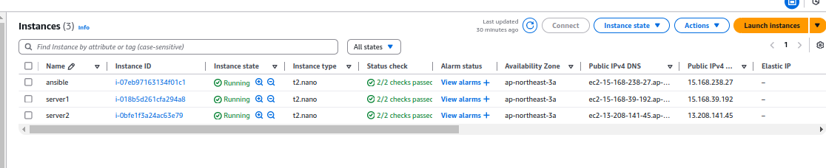
First instance - Ansible
Two instance - Server1 and server2

- Login in Ansible EC2 instance and use these commands

→ switch as root
sudo su -

→ update packages
apt update -y

→ run the following command to include the official project’s PPA (personal package archive) in your system’s list of source
apt-add-repository ppa:ansible/ansible

→ Next, refresh your system’s package index so that it is aware of the packages available in the newly included PPA:
apt update

→ Following this update, you can install the Ansible software with:
apt install ansible -y

→ Check ansible version
ansible --version

→ Go the hosts and add your server1 and server2
nano /etc/hosts



Add : 15.168.39.192 server1
13.208.141.45 server2

→ Generate ssh key from ansible server
ssh-keygen -t rsa
And
Press - Enter → Enter → Enter
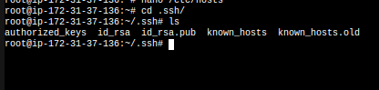
Your you can see ssh keys of public key and private key

→ Copy the public key (id_rsa.pub) and paste it in athuorized_key on server1 and server2

cat id_rsa.pub

→ Go to the server 1 and server 2
→ Login server1 and paste this public key in .ssh/athuorized_key

nano .ssh/authorized_keys

Save it and come out from the shell

→ Login server1 and paste this public key in .ssh/athuorized_key

nano .ssh/authorized_keys
Save it and come out from the shell

→ Return to the Ansible server and check if the ping is working on server1 and server2.

ping server1
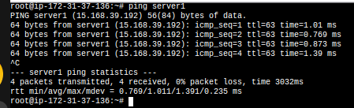
ping server2
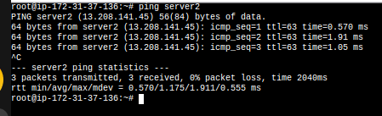

It is working fine in Ansible server

→ Create a directory in the name of Ansbile
mkdir ansible

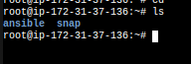

→ Get in the Ansible directory
cd ansible

→ Create a inventory file and add these hosts
nano inventory
[webservers]
server1
server2 (save it and come out from the shell)
→ Create ansible.cfg file and these lines
nano ansible.cfg
[defaults]
inventory=/root/ansible/inventory
remote_user=ubuntu
ask_pass=false (save it and come out from the shell)

→ For testing purpose, we need to install nginx in server 1 and apache in server2 from ansible server
→ Create a yml file for install nginx and apache in server1 and server2
nano install_webservers.yml
---
- name: Install Web Servers
hosts: webservers
become: true
tasks:

- name: Install Nginx on server1
apt:
name: nginx
state: present
when: inventory_hostname == 'server1'

- name: Install Apache on server2
apt:
name: apache2
state: present
when: inventory_hostname == 'server2'

- name: Ensure Nginx is started and enabled on server1
service:
name: nginx
state: started
enabled: yes
when: inventory_hostname == 'server1'

- name: Ensure Apache is started and enabled on server2
service:
name: apache2
state: started
enabled: yes
when: inventory_hostname == 'server2'

(save it and come out from the shell)

→run ansible yml file following this command

ansible-playbook -i /root/ansible/inventory install_webservers.yml

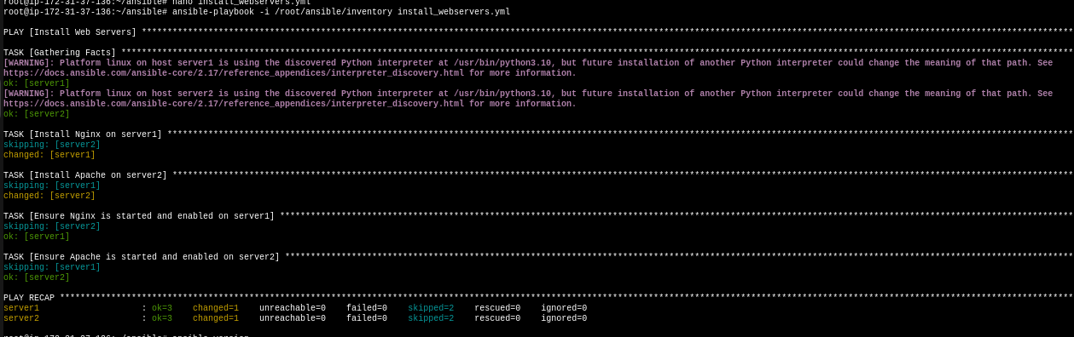

Here you can see installing nginx and apache each servers and you can test by copy each servers ip and paste it browser.

